PROVIDENT LIFE AND ACCIDENT INSURANCE COMPANY
(Herein called the Provident)
1 Fountain Square, Chattanooga, Tennessee 37402

POLICY AMENDMENT #7

This amendment issued by the Provident is
attached to and made part of Policy 127982-0001
issued to
Nagle Hartray Danker Kagan McKay Penney Architects Ltd.
as Policyholder

The Covered Person information shown on page 3 is amended as follows:

COVERED PERSON

To be a Covered Person under this Policy, an employee must (a) be an Eligible Person; (b) be accepted for coverage under this Policy; (c) make premium payments when due; (d) complete the Eligibility Waiting Period; and (e) meet the requirements of Active Work and When Coverage Becomes Effective in Section VI - Coverage Provisions.

Contributions

Class 1 Employer pays the cost of this insurance.

Class 2 Employee pays the cost of this insurance.

Payment of the premium for the coverage provided by the Policy as amended on and after the effective date of this amendment will constitute acceptance of the terms of this amendment by the Policyholder and/or Employer Participant.

This amendment is effective July 1, 2004.

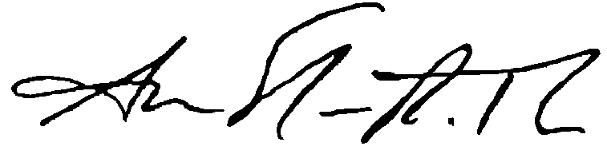

VICE-PRESIDENT, CORPORATE SECRETARY AND ASSISTANT GENERAL COUNSEL

A127982LTD#7(eff7-1-04)

